**NAME: KELVIN CHAN**

**SUBJECT: Reminder Task**

Interface:

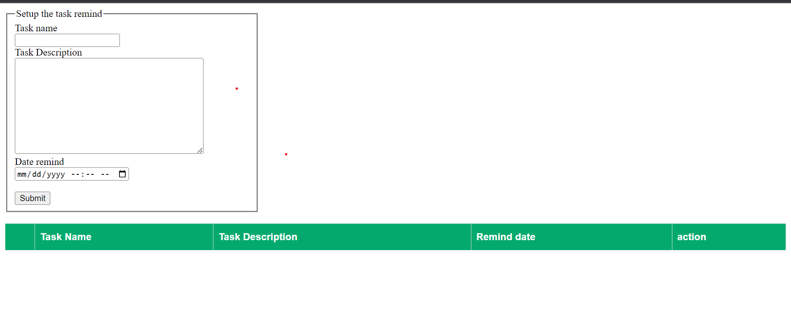This is my reminder task. Task Name and Task Description we can insert every word for reminder ours. After we can set the date at Date remind to reminder ours.

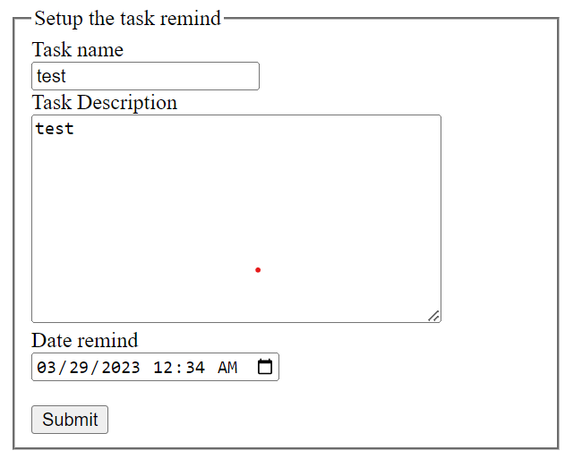



Start, we can setup the task reminds like picture. If click the submit it will show an alert for notify task setup success.

Show Interface:

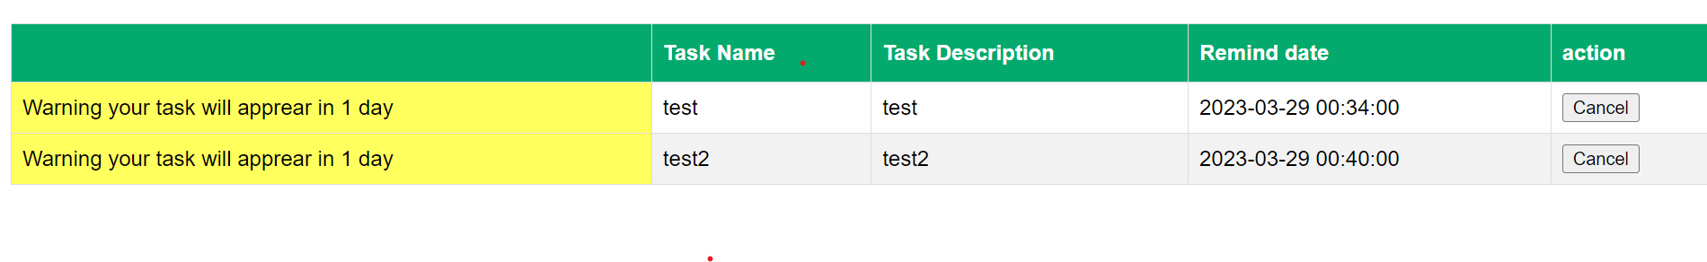

After setup remind the remind will show at interface like picture, if the date is expired it will show a alert for notify user like “Expired”. So, if the task will expire more one day the text will change to color yellow; conversely the task is expired in today will change to color red.



If it success will show a alert for info ours.Like 'Task setup success'. After, the task name, task description and time will show at interface.





If the date is expired , will show alert for ours (Expired) and the interface column will become color red.



Finally, i have create a cancel button to cancel or delete the task data. When cancel the task data it will delete at database.When the data task is delete the interface will also will delete.

